Planning:

**I chose an online website that deal with shoes dealing. there are five pages in my website. First page is men that is about men shoes. Second page is women that is about women’s shoes. third page is kids shoes that is about kid’s shoes. fourth page is about us that got all the information about the company. Fifth page is contact us where you can contact us through different methods.**

Goals:

**. display shoes for all genders and people of every age.**

**. provide much and much variety.**

**. give the best quality to the customers.**

**. provide our customer’s suitable prices.**

Site map:

**Men page: Men shoes of different variety.**

**Women page: Women shoes of different variety.**

**Kids page: Kid’s shoes of all variety.**

**About us page: All information about the website.**

**Contact us page: Where you can contact us on.**

LOCATION:

**Discover the hidden gem nestled in the heart of London Harringay Finsbury. Our location offers perfect blend of tranquillity and excitement.**

MIND MAP

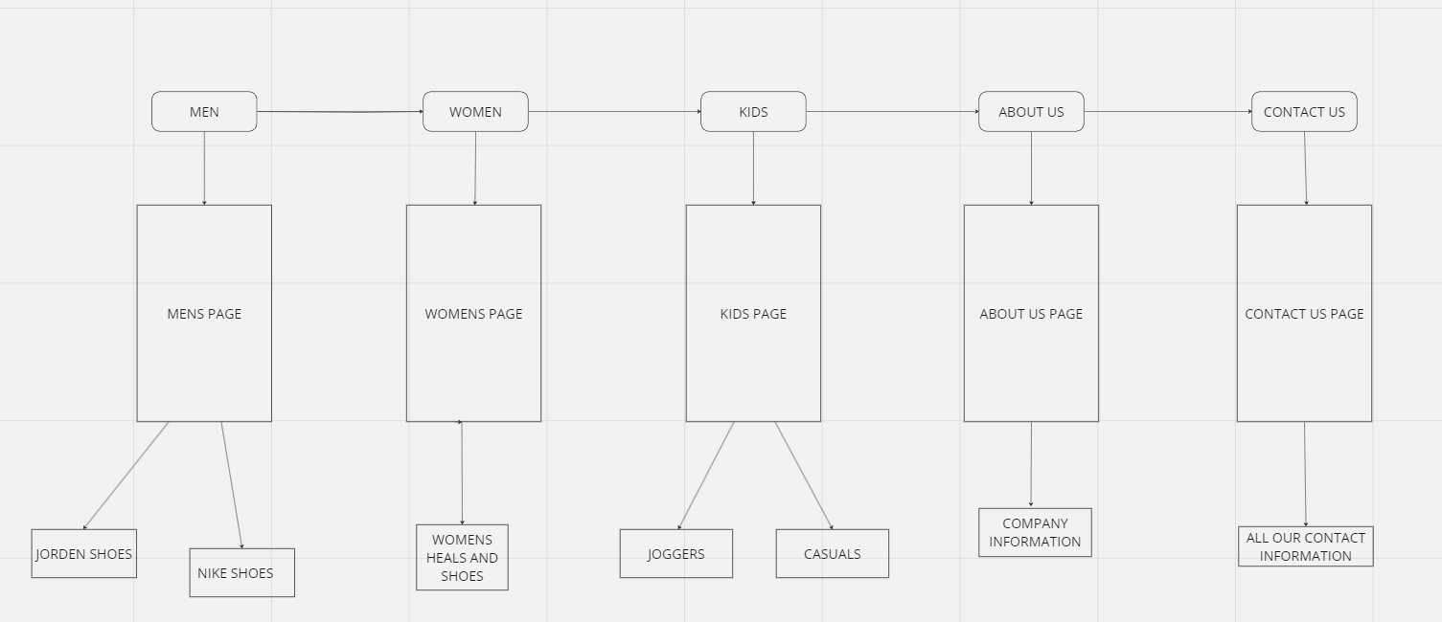

Here’s a link to my website:

[**https://sameer1554.github.io/sam/**](https://sameer1554.github.io/sam/)s

HTML & CSS FILES:

MEN’S PAGE

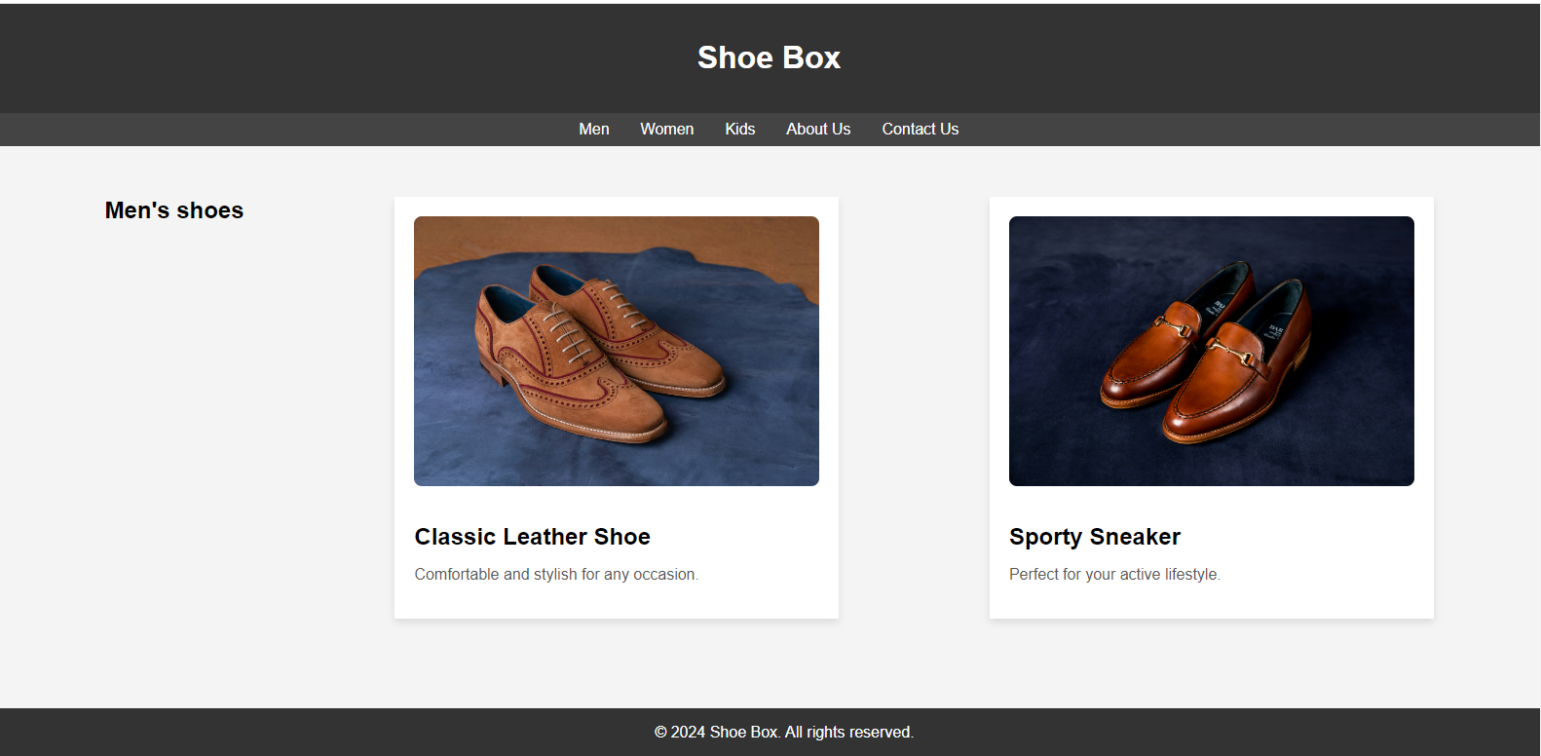

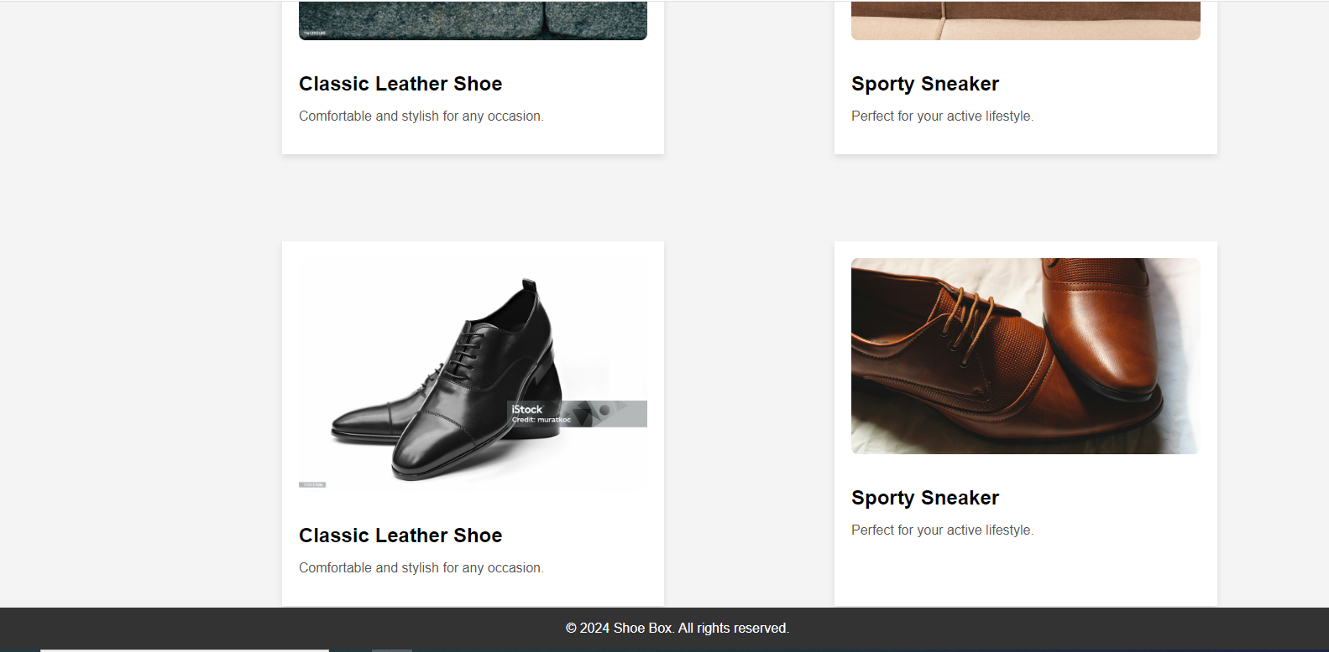

Coded version

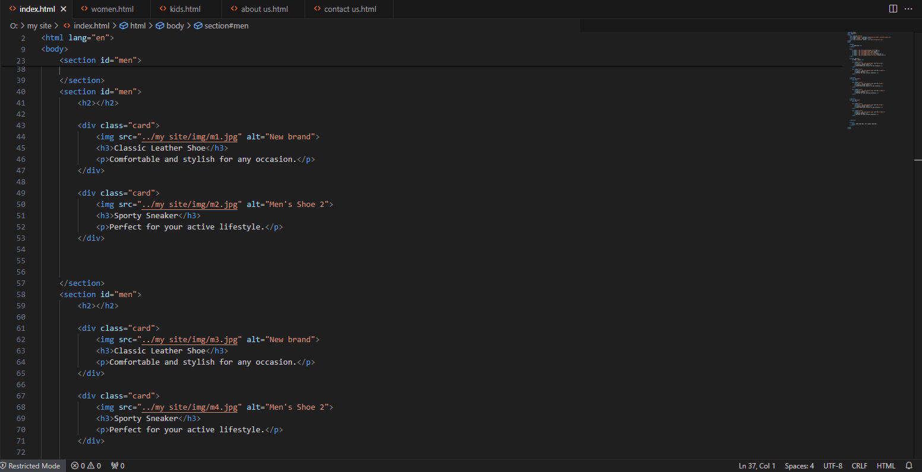

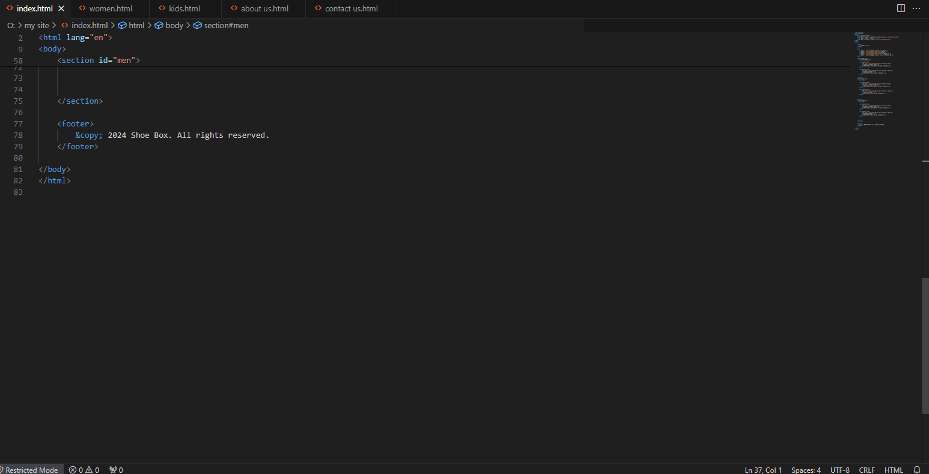

WOMEN’S PAGE

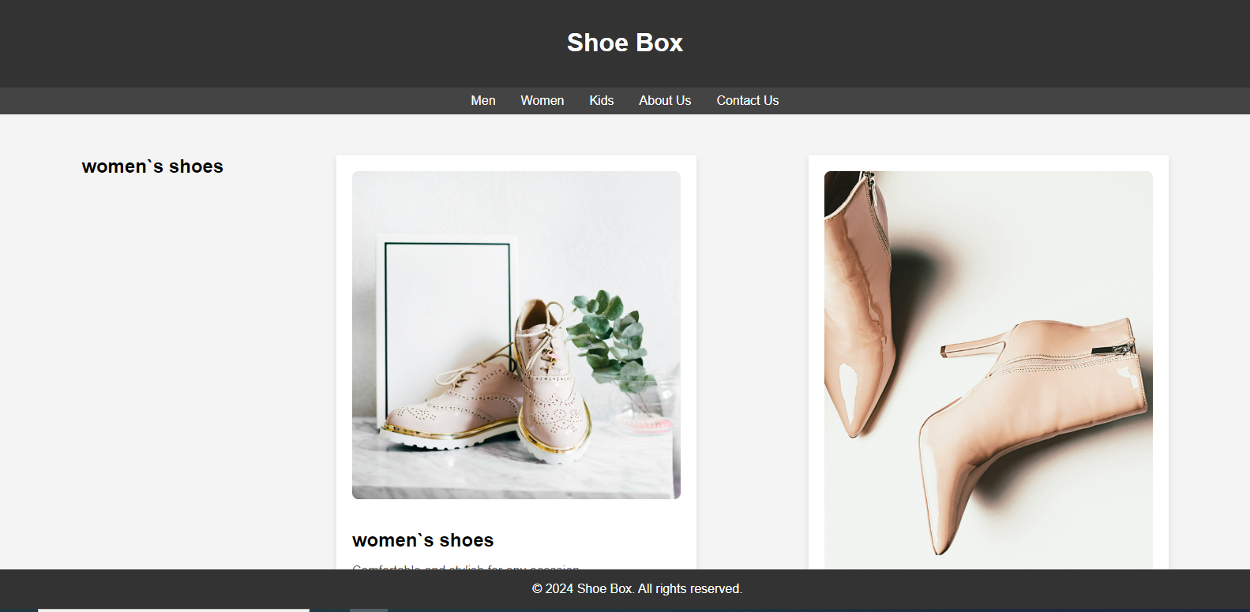

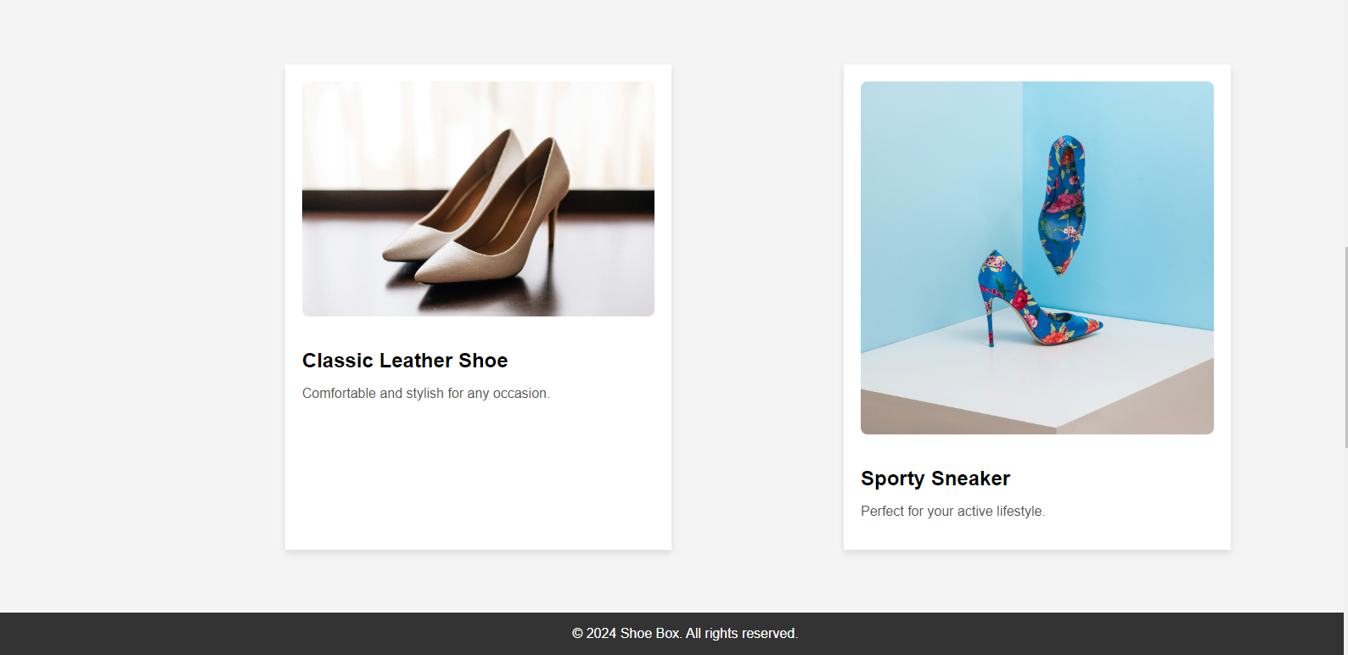

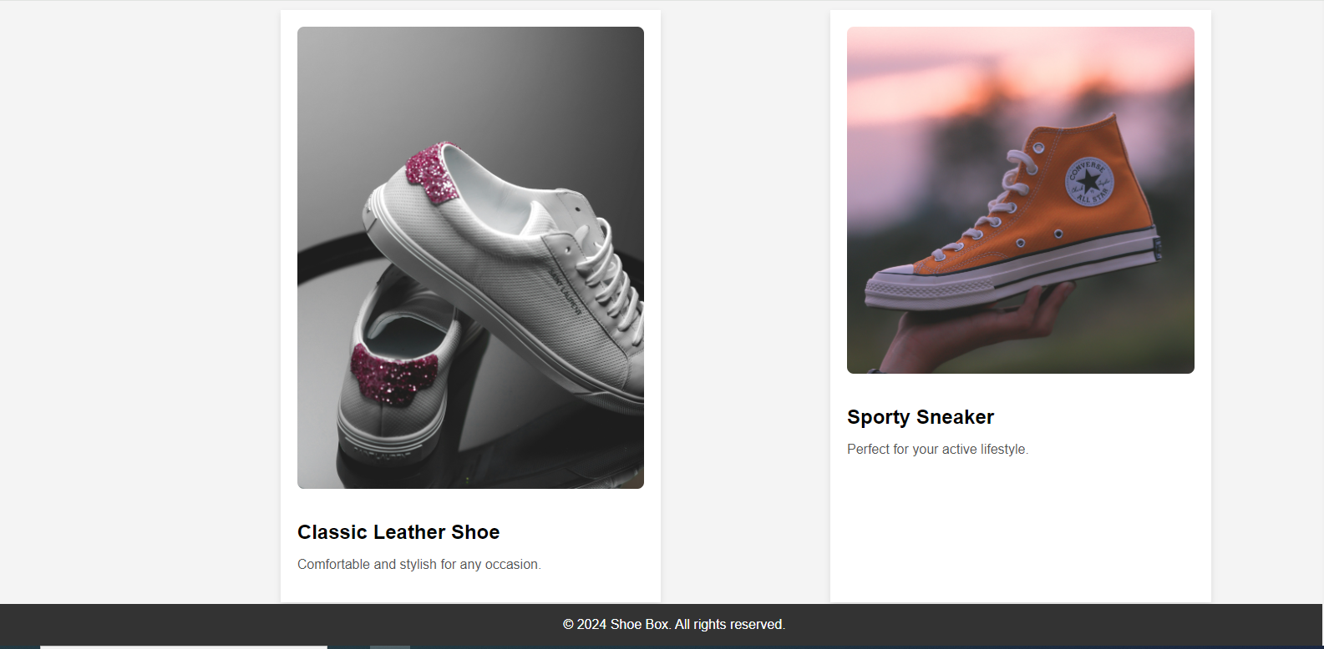

CODED VERSION

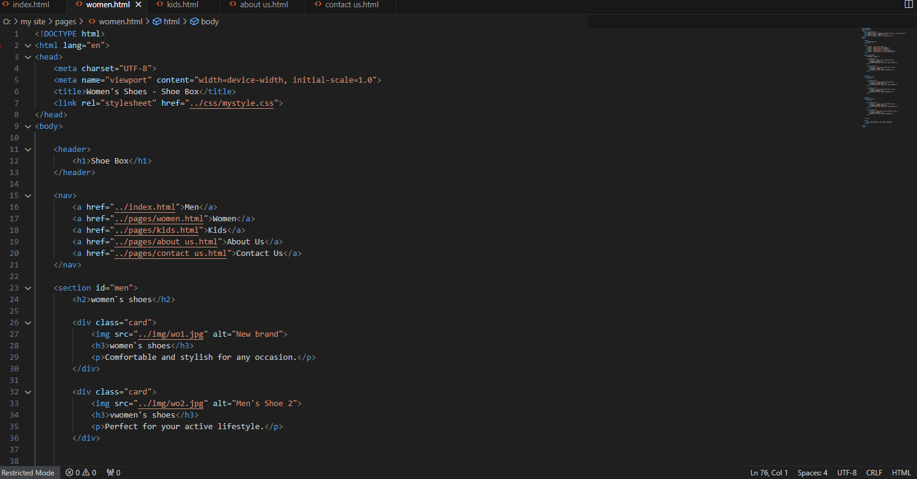

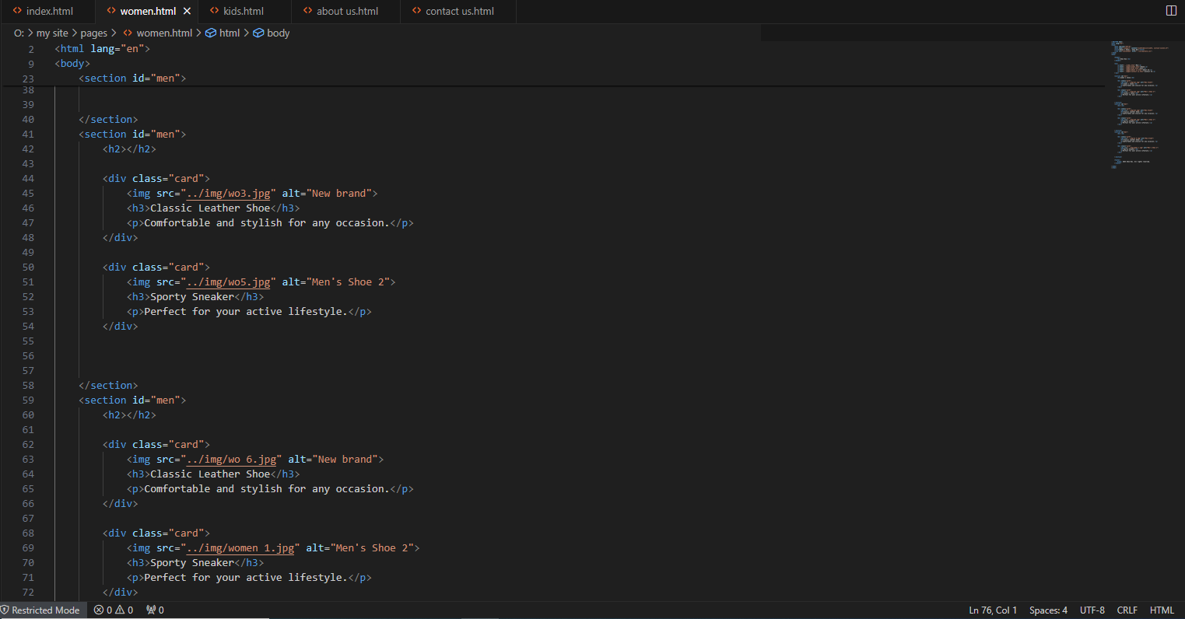

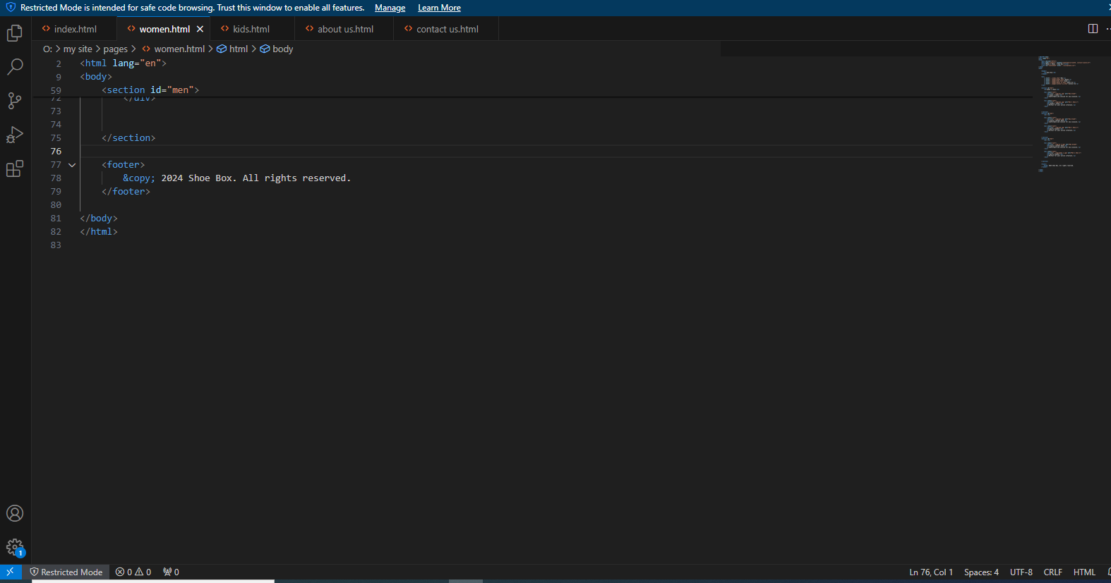

KID’S PAGE

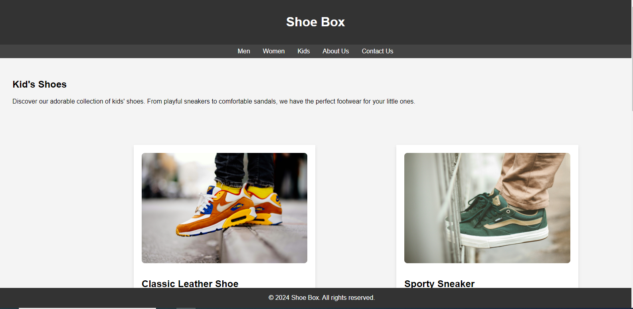

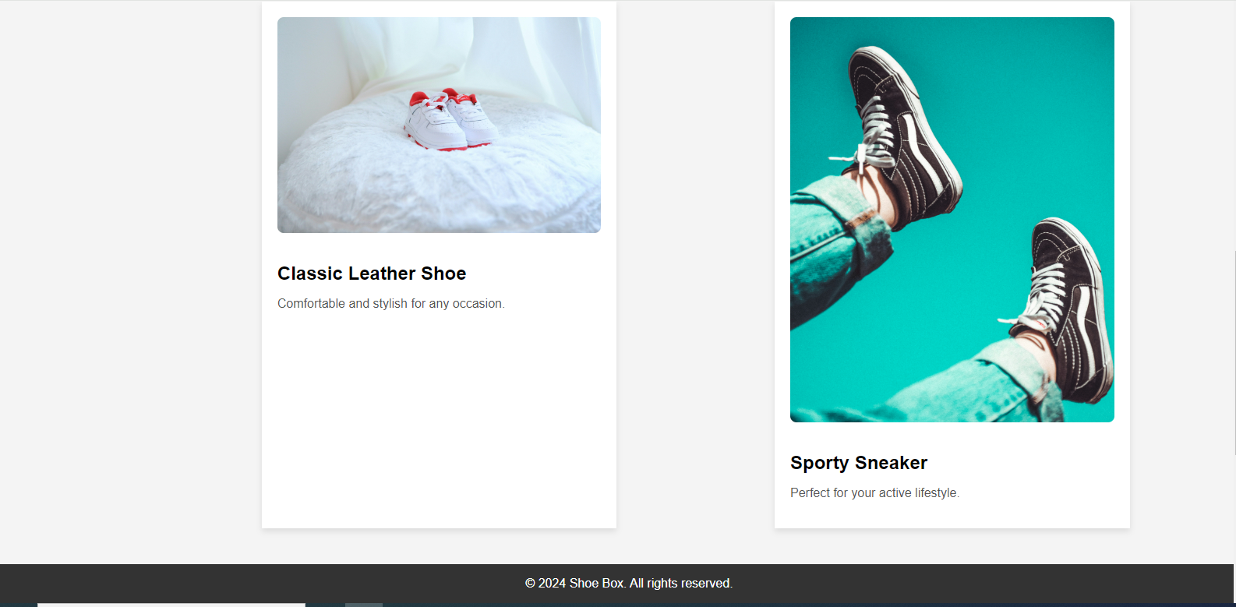

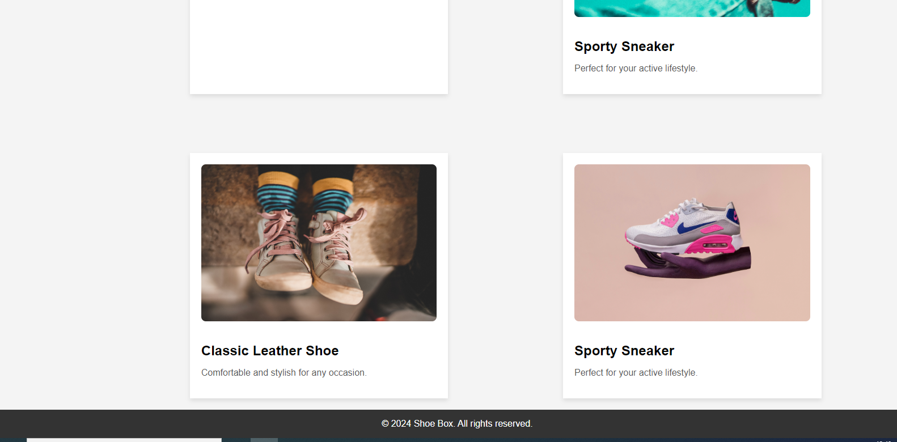

CODED VERSION

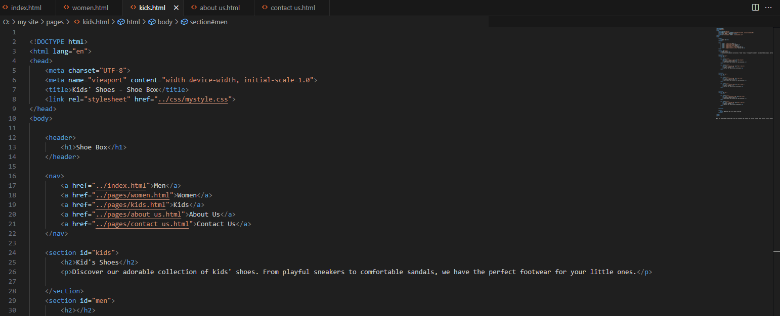

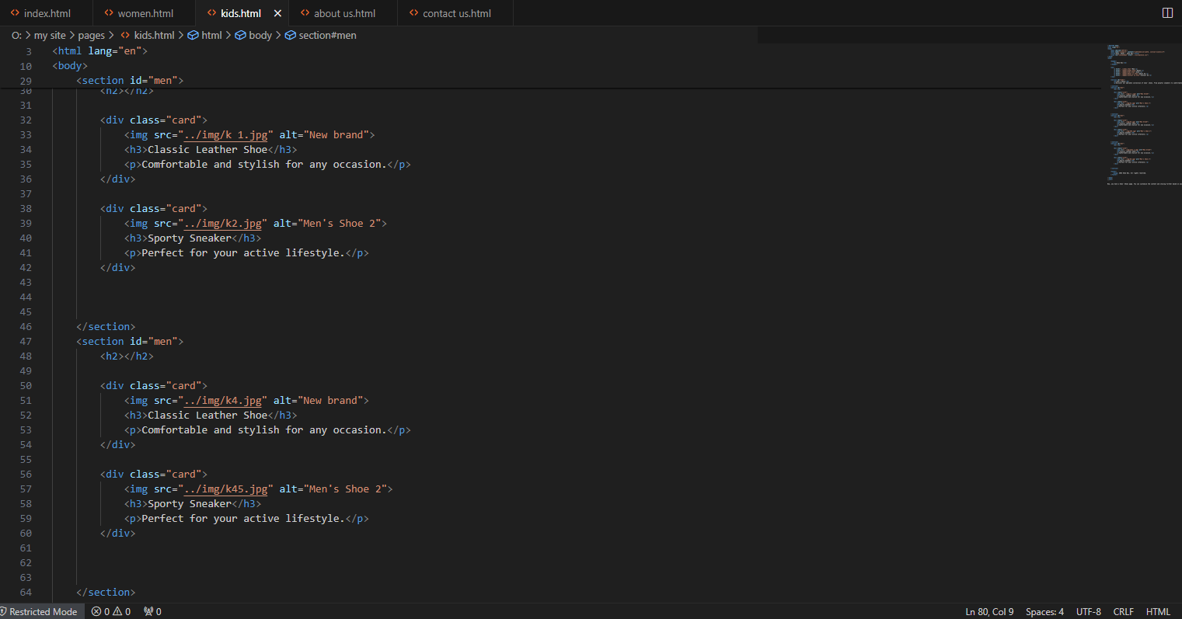

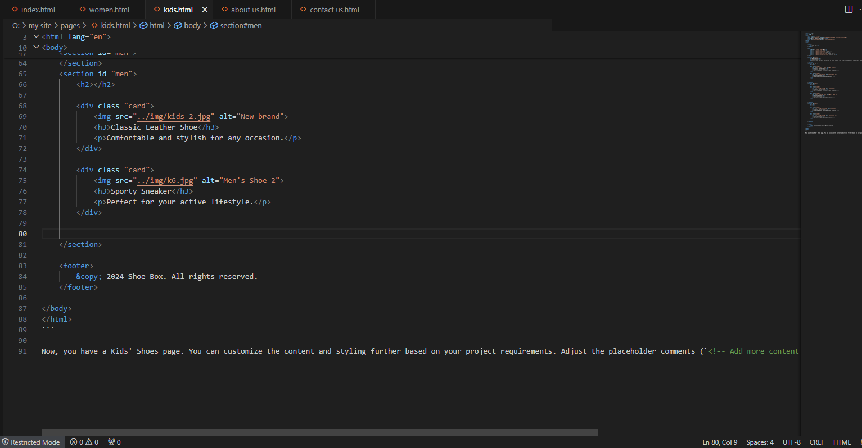

ABOUT US PAGE

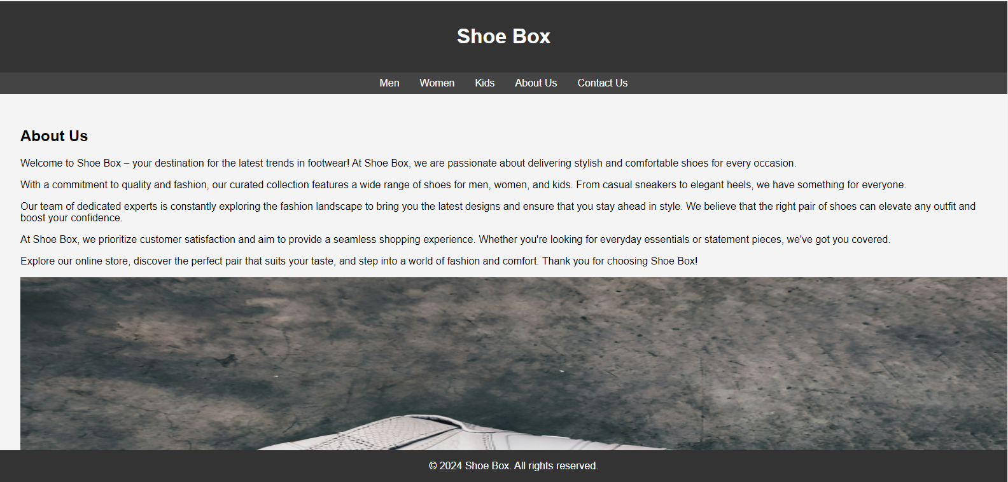

CODED VERSION

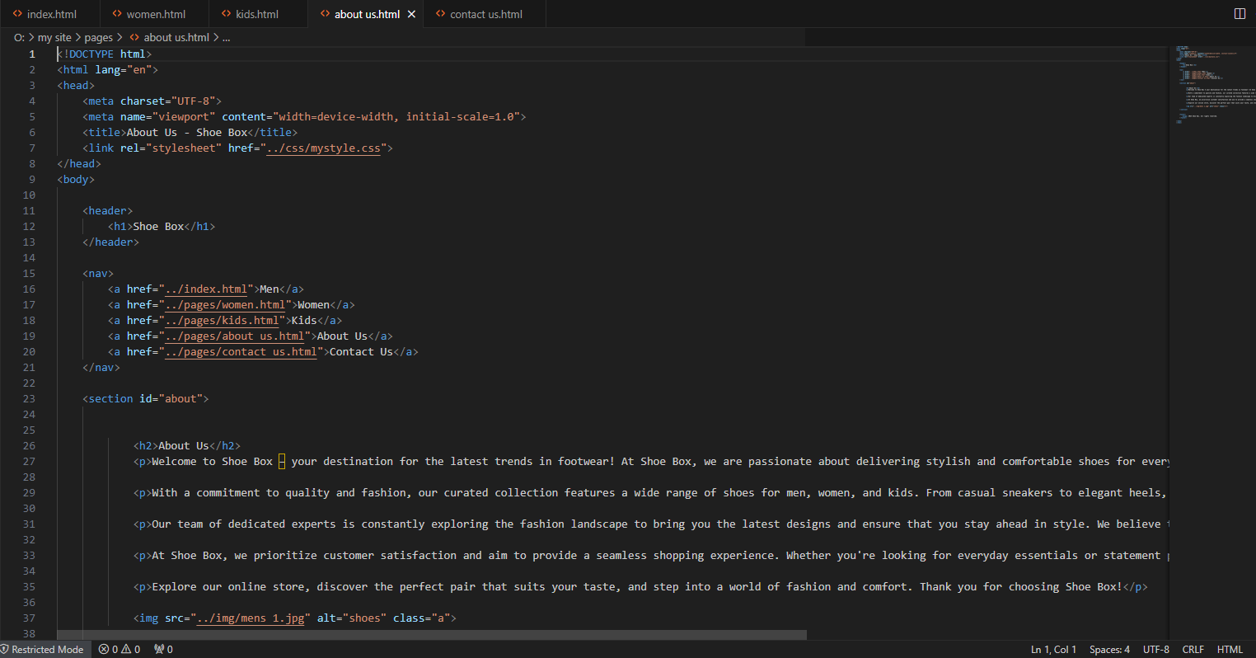

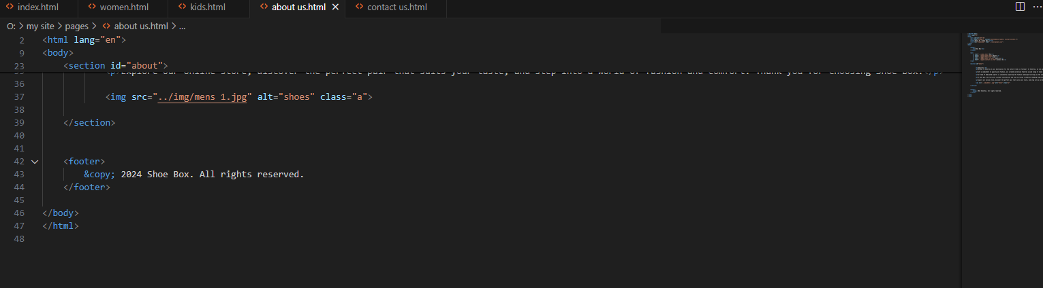

CONTACT US PAGE

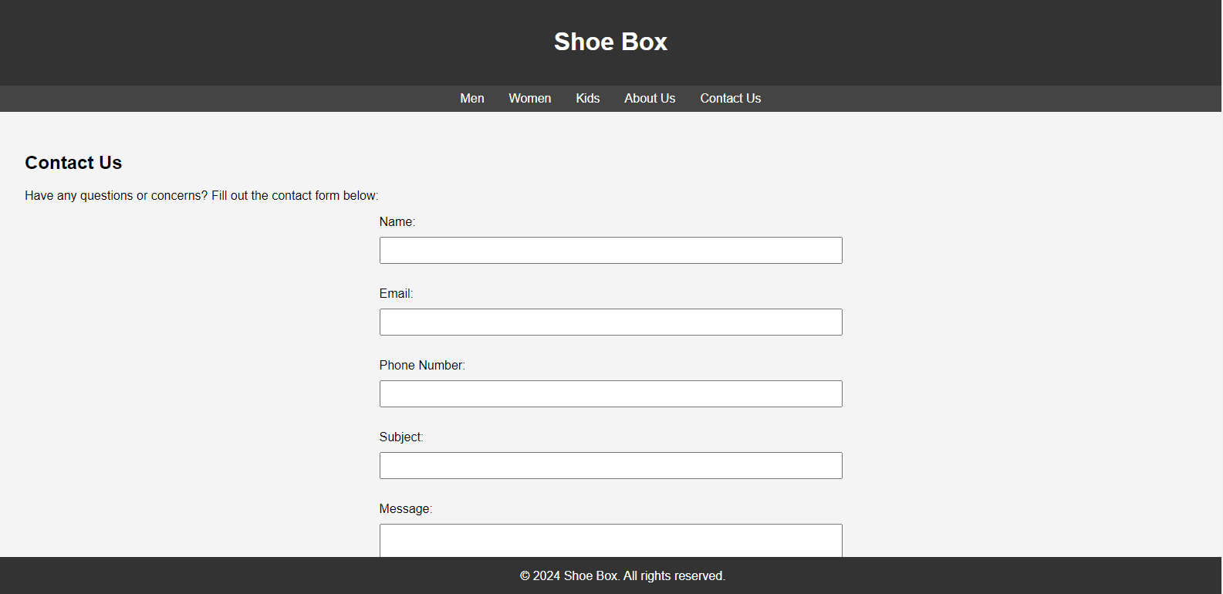

CODED VERSION

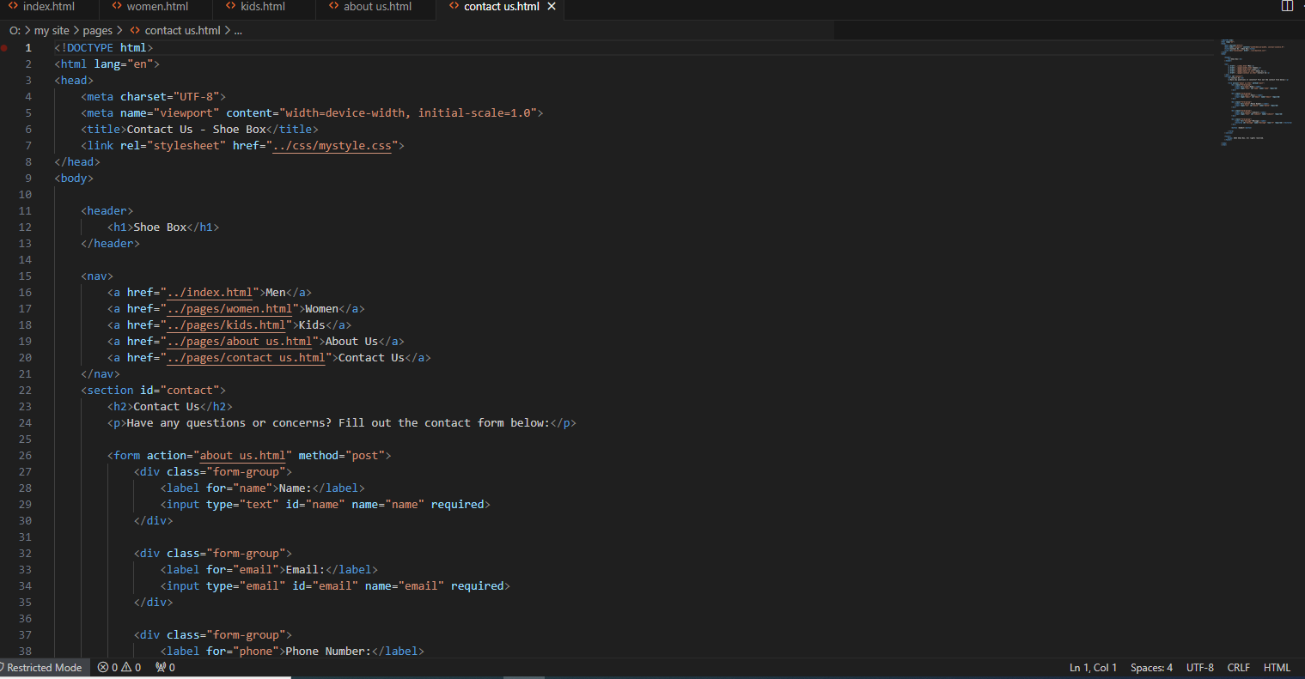

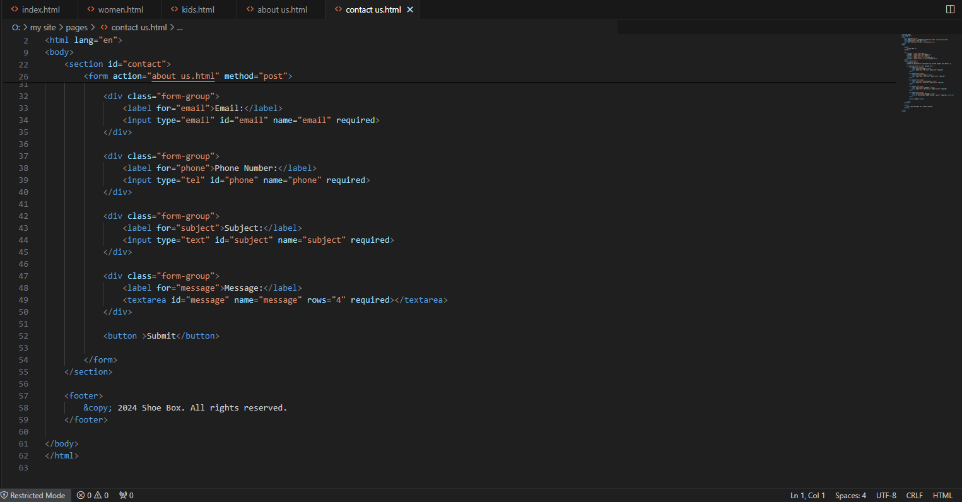

CSS code

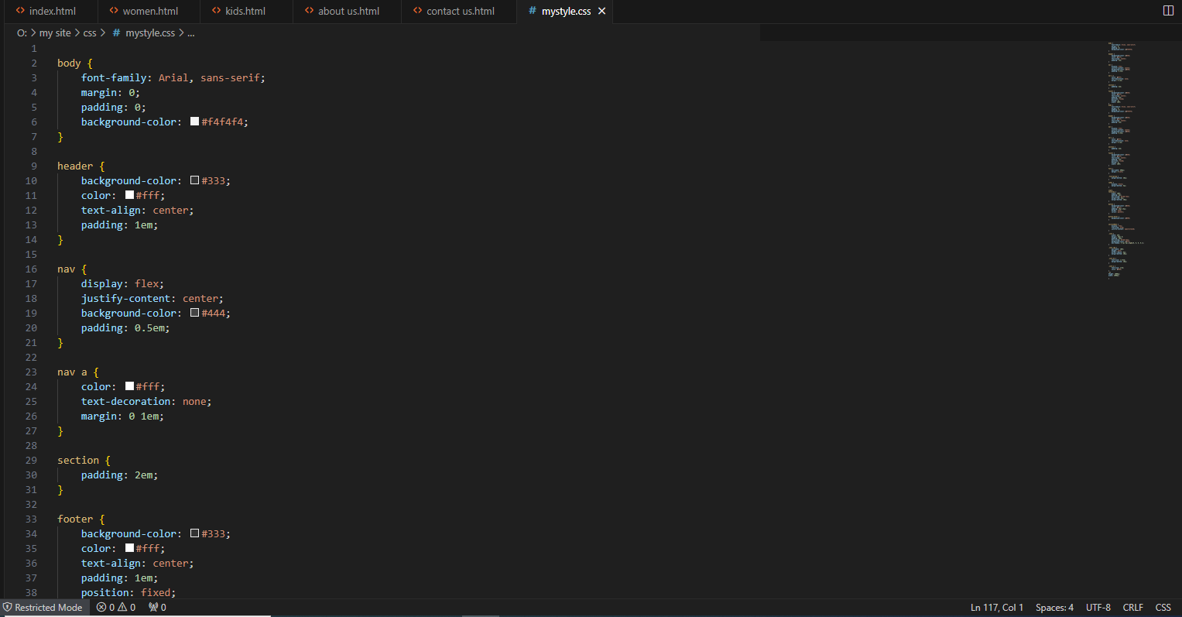

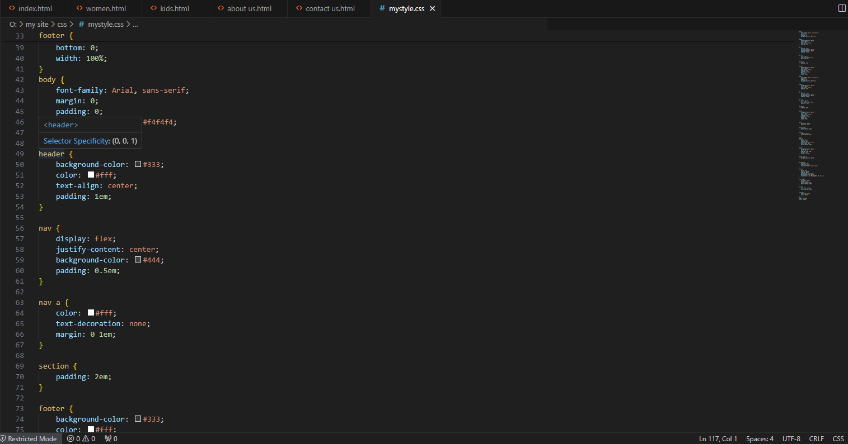

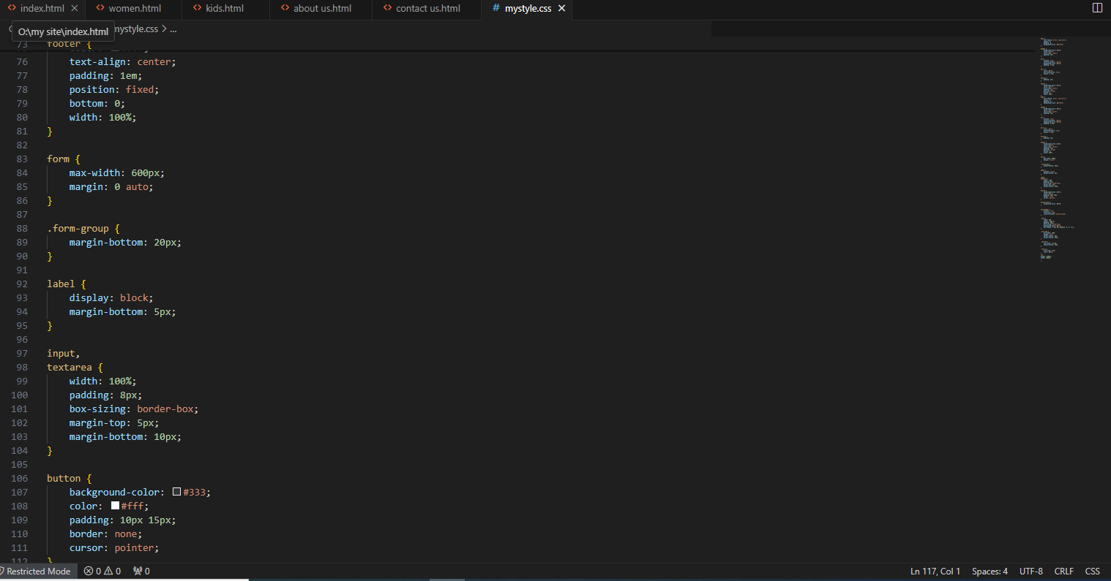

My design

Men’s page

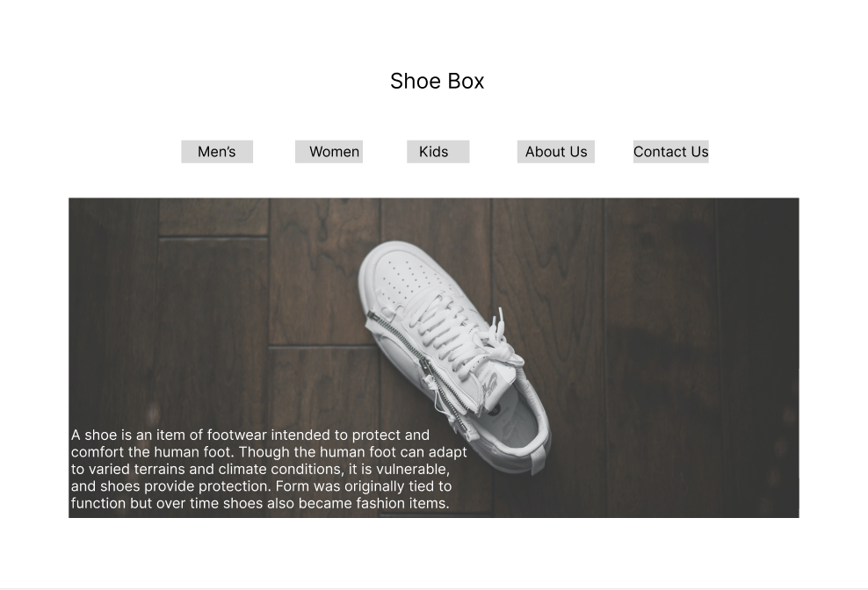

Women’s page

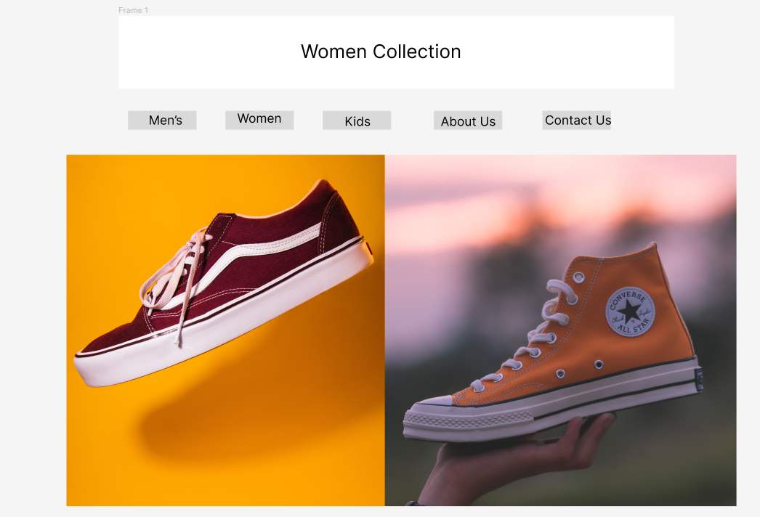

Kid’s page

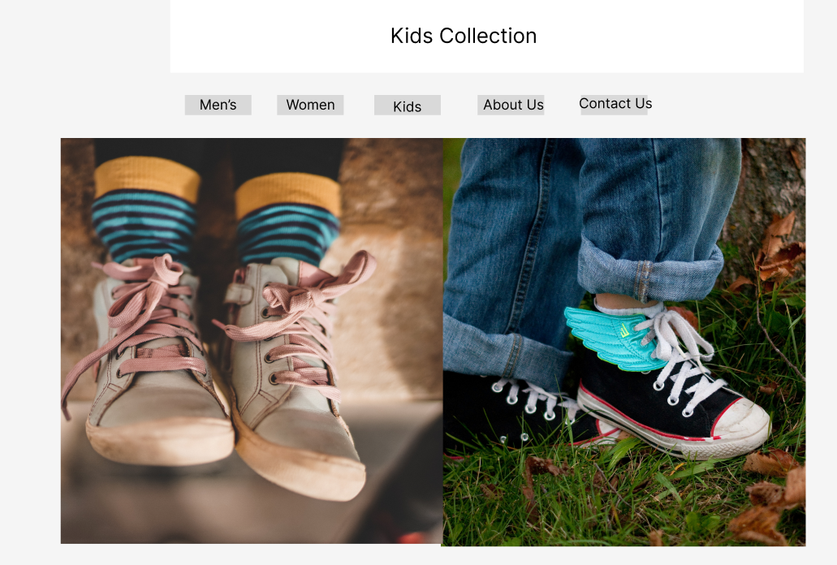

About us

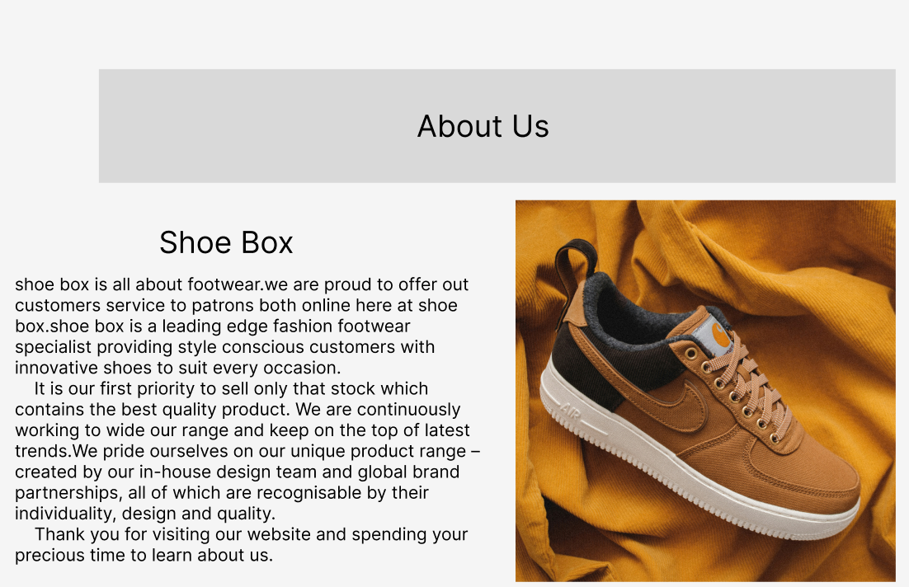

Contact us

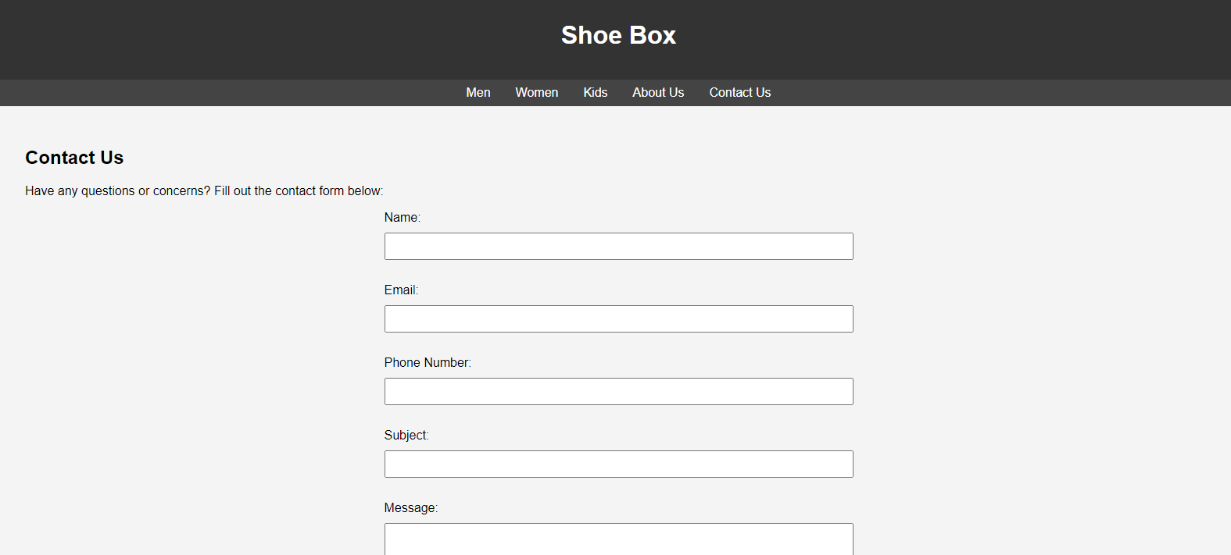

Development Diary

Task Number One

My Plan for Web-designing

|  |  |  |  |  |  |  |
| --- | --- | --- | --- | --- | --- | --- |
| Monday | Tuesday | Wednesday | Thursday | Friday | Saturday | Sunday |
| It is the exact day of web-designing lecture. From 10;45 to 12;15 |  | Learn how to use visual studio code and how program run through it. |  |  |  | Study with my brother through unit’s notes. |
| The next lecture of web-designing starts from 01;15 to 02;45 |  |  |  | Learn how to create pages and how to run them on visual studio code. |  |  |

Explanation

I started my course on September 11 approximately and that day I started my web-designing as well because on Monday I took classes of it from Mr. Andree. 1st day I learned what is web-designing and how it works benefits basics and all that. I always preferred to study at home on Wednesday, Friday and Sunday because in these days I was free to learn things about web-designing with my brother. From Mr. Andree I learned the basics but to more expert in this I took help from my brother because he is very familiar with this module. On Wednesday, he taught me about visual studio code and told me about every single about it. On the other hand, Friday was the day when I learned how to create folders of any website and on Sunday my brother and I revised all things through module notes. To cut the story short, 4 days a week I study and 3 days I prefer to learn other modules.

**Study plan table**

|  |  |  |
| --- | --- | --- |
| Study day and date and plan classroom activities | My Planning for Tutorials and classroom activities | How I participated in the classroom |
| **25 September 2023**  I learned how to change the size of font and how to add different font in different lines as well and learned how to change the color of fonts in each line. | I do as Mr. Andree did in the classroom but I felt some difficulties in it so I took help from my classmate and revised this task in home. | I sat with my classmate to do this and overcome my difficulty about it. I also learned that there is a lot of google sites which through we got help about web-designing. |
| **02 October 2023**  I learned how to create slides and how to change the background color of pages I also learned how to add different color backgrounds in different pages as well. | It is difficult and tricky but not too hard to understand. I visited to my teacher and asked him to taught me one more time than I got success in task and in home I saw video on YouTube about it to get more familiar. | In class, I faced difficulty to do this task but teacher helped me about it & I got succeeded about it I also learned that there is some code which is written between curly brackets and automatically page color change. |
| **09 October 2023**.  I learned how to add pictures in pages and how to make slide of them I also learned how to manage the size of pictures and how to adjust them as well. | It is easy to understand and perform but quite difficult when adjusting pictures. I took help from my brother about it and see how he did it. | My brother helped me about it. Although it is easy but bit tricky, I tried many times but it didn’t work so after learned more deeply from my brother I got succeeded in it. |

Introduction:

The purpose of the report is to document the development processes and key aspects of the creation of my website (SHOE BOX). This report describes the requirements, design creation and tools used in the development of the website.

Project Overview:

SHOE BOX is a shoes retail shop providing high quality shoes and soles across the world. It is known by the high-quality shoes it provides across the world. The website usually targets the audience aged 16-24 years old. It provides all the information about the shoes that are trending and in the interest of youth.

Requirements:

The following requirements are as follows:

Responsive Design: The website should be accessible and functional across various devices and screen sizes.

Pages:The website must have minimum of five pages interlinked with each other.

HTML & CSS:The website must have HTML and CSS applied in it.

User friendly navigation:The website must have navigation buttons and all other buttons working properly.

Development Process

Planning and Design

The development process began with conceptualization and wireframing of the website layout and structure. Key design decisions included:

**Color Scheme:** #FFF/WHITE. **/**  Dark charcoal / #333333

**Typography** font-family: Arial, sans-serif

**Layout**: The website will be having name of Brand on the top. A navigation bar must be placed just under the name of the brand. A series of cards is placed in the pages. The footer will contain the banner that says it is a private shop and all rights are reserved.

|  |  |  |
| --- | --- | --- |
| **Tools** | **Description** | **Uses** |
| **<Link>** | **To link css files** | **before head** |
| **<ul>** | **Unordered list** | **In body** |
| **<Li>** | **List item** | **In ul** |
| **<div>** | **Make a separate block** | **Inside page** |
| **<a>** | **Link page** | **For navigation** |
| **<h1>** | **For headings or bigger fonts** | **On headings** |
| **<Img>** | **Add image** | **In cards** |
| **<form>** | **Form for user information** | **Contact page** |

|  |  |  |
| --- | --- | --- |
| **Tools** | **Description** | **Uses** |
| **Background color** | **Add background color** | **In the background** |
| **Text aligns** | **Adjust position of color** | **On text** |
| **Size** | **Size of fonts** | **On text** |
| **Color** | **Color of fonts** | **On text** |
| **Font size** | **Size of fonts** | **On text** |
| **Font family** | **Define fonts** | **On text** |
| **Padding** | **Space inside the div** | **In a div** |
| **Margin top** | **Space from above** | **on a div** |
| **Margin left** | **Space from left** | **on a div** |